Enter the Student Learning and Licensure portal using this URL: https://login.watermarkinsights.com/connect/ucdenver.
You will use your CU Denver login credentials to sign in.
Once you have signed in to SL&L, you will see a screens with the following:
1. Click the "In Progress" button along the left sidebar menu.
2. Click on the course.
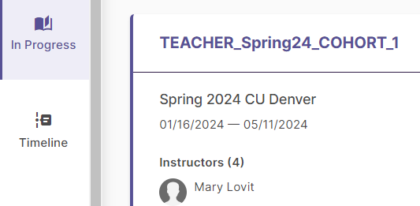

3. Click on the section.
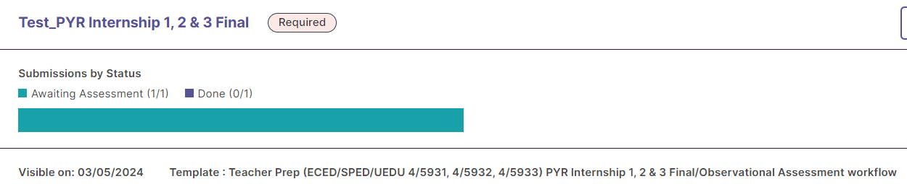

4. Click on the student's name you will be assessing.
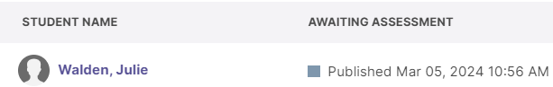

5. In the right sidebar “Assessment Panel”, click on "View Rubric Details" to expand the rubric.

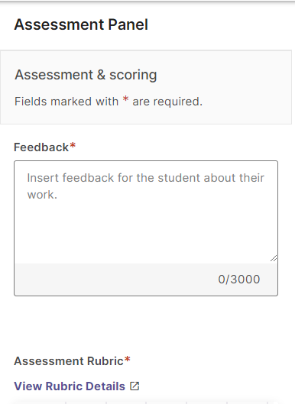

6. Click the box for the level of each element to score the student on that element.
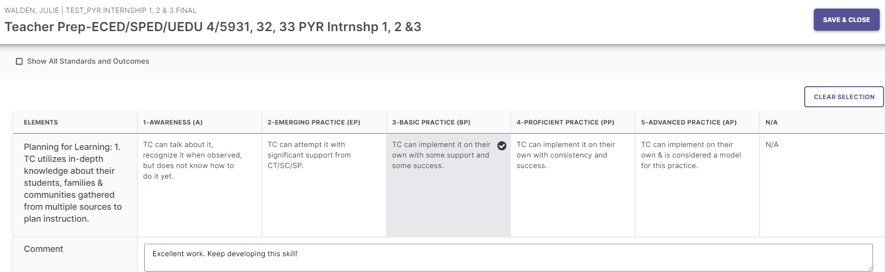
Optional: Show or Hide aligned Standards and Outcomes by checking this box.
Optional: Leave Comments.
7. Save and Close

8. When complete, click “Submit” on the upper right-hand corner of the student record screen.
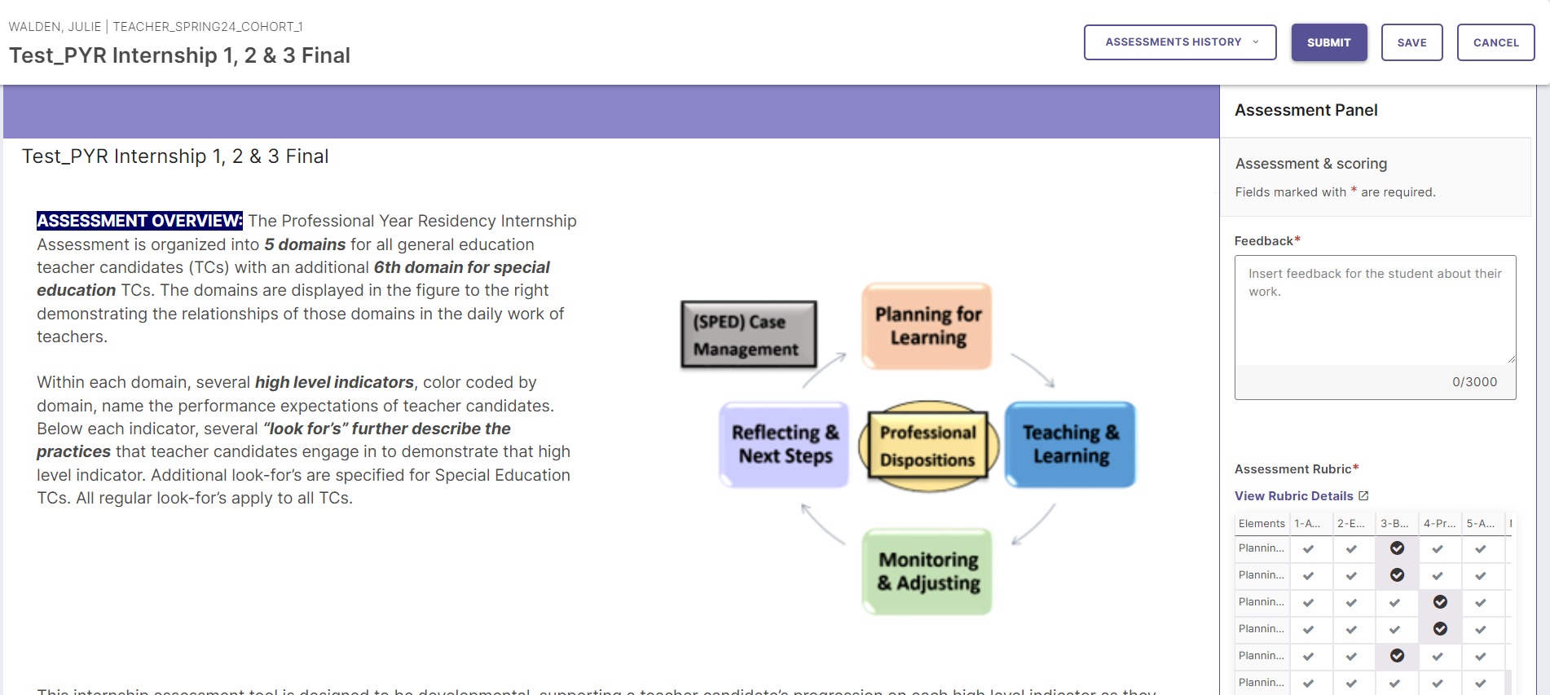
CONTACT SEHD.HELP@UCDENVER.EDU with any questions or to request assistance.

