Graduate Degree Audits (SEHD Faculty Guide)

Overview
Graduate degree audits ensure that students meet all requirements for graduation and are required for all graduating students. Graduate audits are currently being implemented across programs, with full rollout expected by Fall 2026.

How Degree Audits Work

Degree Audit Logic Flow
Student Admit Term
↓
Catalog Year
↓
Degree Audit Output
Interpretation:
- Student admit term determines the catalog year
- Catalog year determines program requirements
- Requirements + completed coursework generate the audit output

Why Degree Audits Matter
- Colorado statute C.R.S. § 23-1-131 requires Colorado public institutions to implement a degree audit process
- Required for graduation clearance
- New for graduate programs (already established for undergraduate)
- Students already have access and may request guidance

Key Concepts

Degree Audit Structure
Student Record
↓
Program of Study
↓
Catalog Requirements
↓
Completed Coursework
↓
Audit Results (Completed / In Progress / Work Not Applied / Not Satisfied)

Faculty Workflow
- Review Student Audit
- Check Against Catalog
- Approve / Request Changes
- Degree Audit & Transfer Change (DATC) Form
- Audit Updated

Important Rules

Catalog-Year Dependency
- Audits are tied to the catalog associated with a student’s admit term
- Example: Fall 2025 → 2025–2026 catalog

Exceptions Handling
Standard Requirements
+
Faculty Exception (DATC Form)
↓
Updated Individual Audit
- Exceptions must be applied individually per student
- Catalog changes apply to all students in that catalog year
- Catalog-level updates can be made once a year (during late fall or spring) and go into effect starting in fall of the following academic year (Example: changes made in late Fall 2025 / Spring 2026 → effective Fall 2026 / 2026-2027 catalog)

Multiple Programs Limitation
Degree Audit (MA, EdS, EdD, or PhD)
Degree Audit (Certificate)
Degree Audit (License or Endorsement)
Degree Audit (Credential)
↓
NOT CONNECTED
- Separate programs generate separate audits
- Audits do not integrate or share information
- Faculty can select a different term or program to “run a different program” audit​

Access & Tools
- Access and run audits through the UCDAccess faculty portal
- Request “DATC Advisor” access if needed
  - Request type “Update Access” as “DATC Advisor”​
  - Justification is “advisor-level DATC audit access”
- Transfer of Credit Form

DATC Form Use Cases
- Course substitutions
- Waivers
- Transfer credit updates

Common Issues
- Missing Requirement → Check catalog alignment → Submit DATC Form if necessary
- Course Not Counting → Verify substitution → Submit DATC Form if necessary
- Transfer Not Applied → Confirm updated form → Submit Transfer of Credit Form if necessary
- Multiple program issue → Run audit for each program

Sample Degree Audits
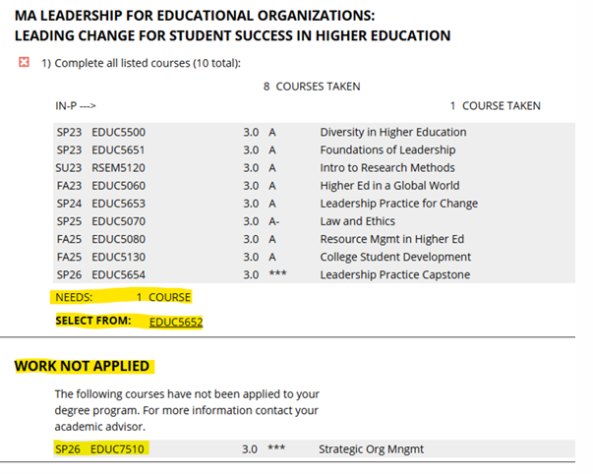
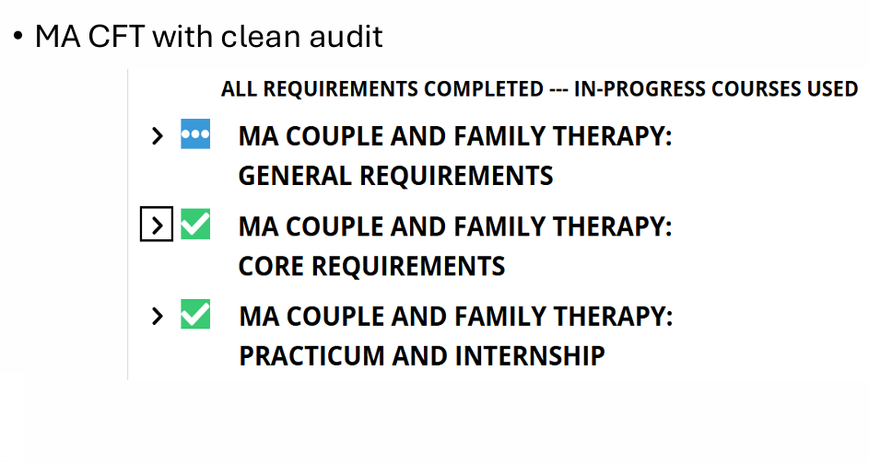

Support
- Contact your Graduate Academic Advisor for program-specific issues
- Email Degree Audit Unit: DAUnit@UCDenver.edu
- Graduate Degree​Audit Information​for SEHD Faculty presentation slides (Spring 2026)

Key Takeaways
✔ All students need a CLEAN audit to graduate
✔ Audits are tied to catalog year
✔ Exceptions require DATC form
✔ Faculty review is critical
✔ Full implementation targeted for Fall 2026

