How To

Make Edits
1. Click 'Login' in the upper right corner of the screen and login with your wiki credentials.
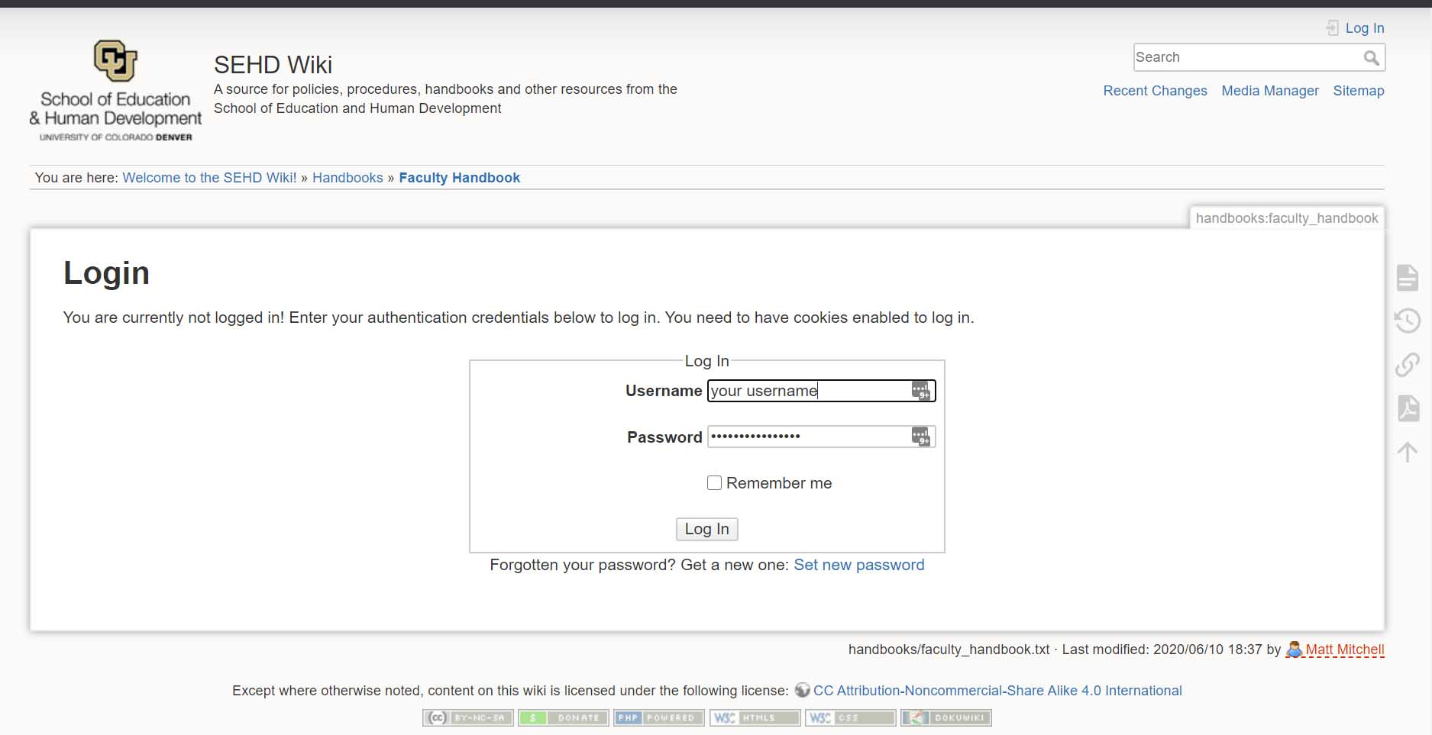1_login.jpg

2. Navigate to the section of the website you would like to edit. In this case we are going to make some edits to the Faculty Handbook.
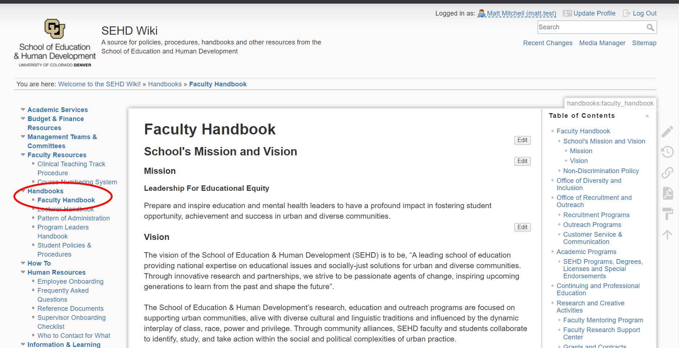2_navigate.jpg

3. Click the “Edit” button that is below and to the right of the section you would like to edit. In this case we want to edit the “Mission”.
Hovering over the edit button for a second before clicking it can prevent it from opening the wrong section.
Sometimes when you click the “edit” button it will load extra sections or the wrong section entirely, if this happens it is best to just hit cancel and go back to the previous page and then hit the edit button again.
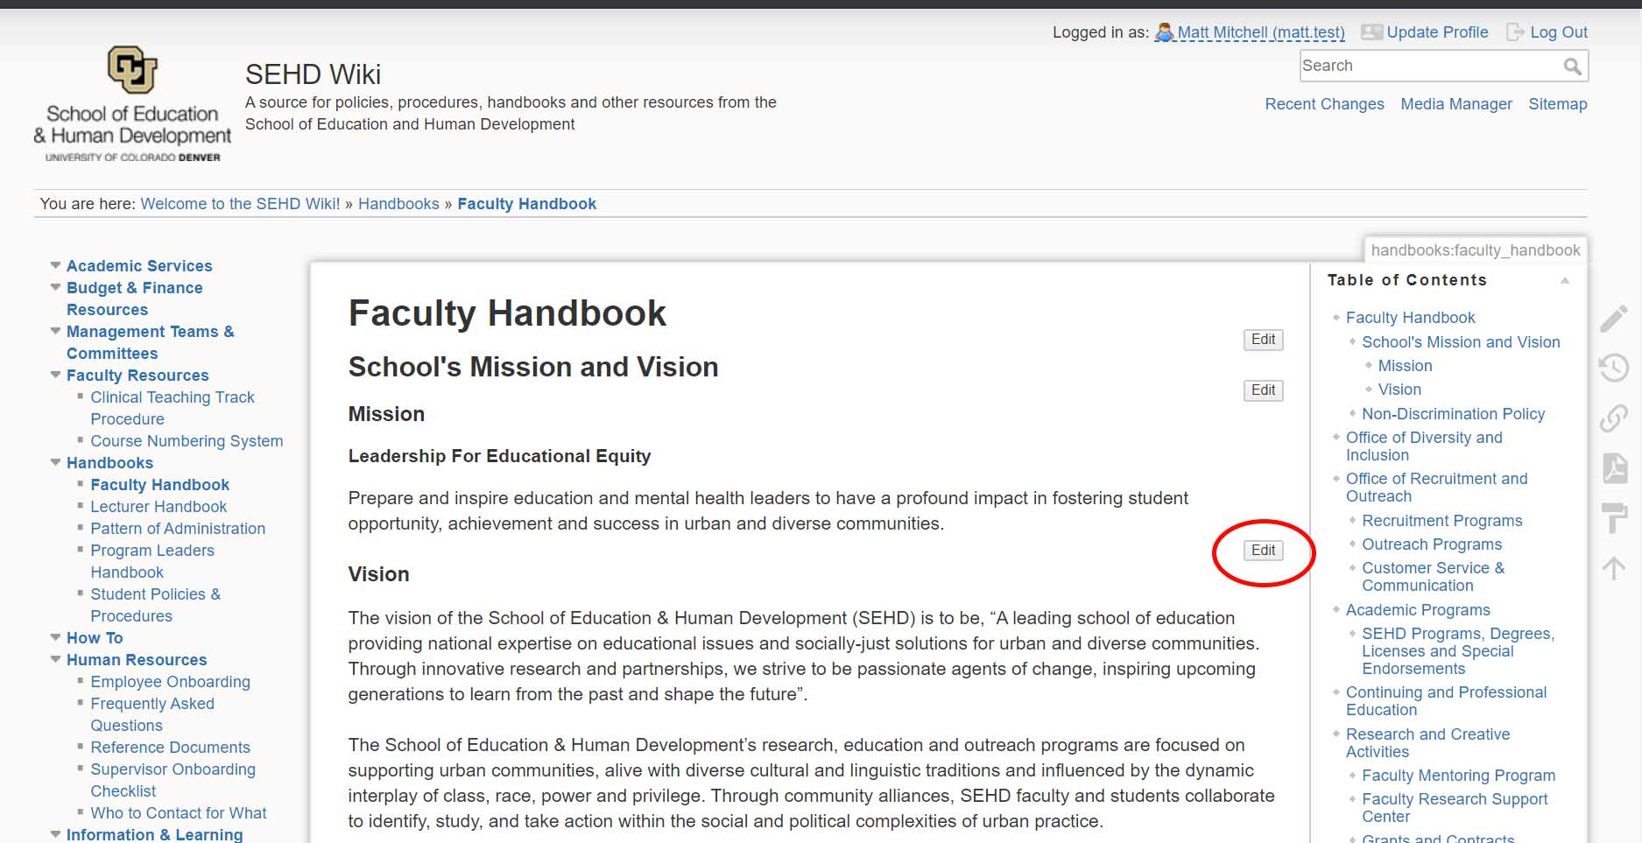3_edit.jpg

4. Make your changes on this page using the editor and click save when you are finished. Every save creates a new version of the document, allowing you to roll back changes to previous revisions if mistakes are made.
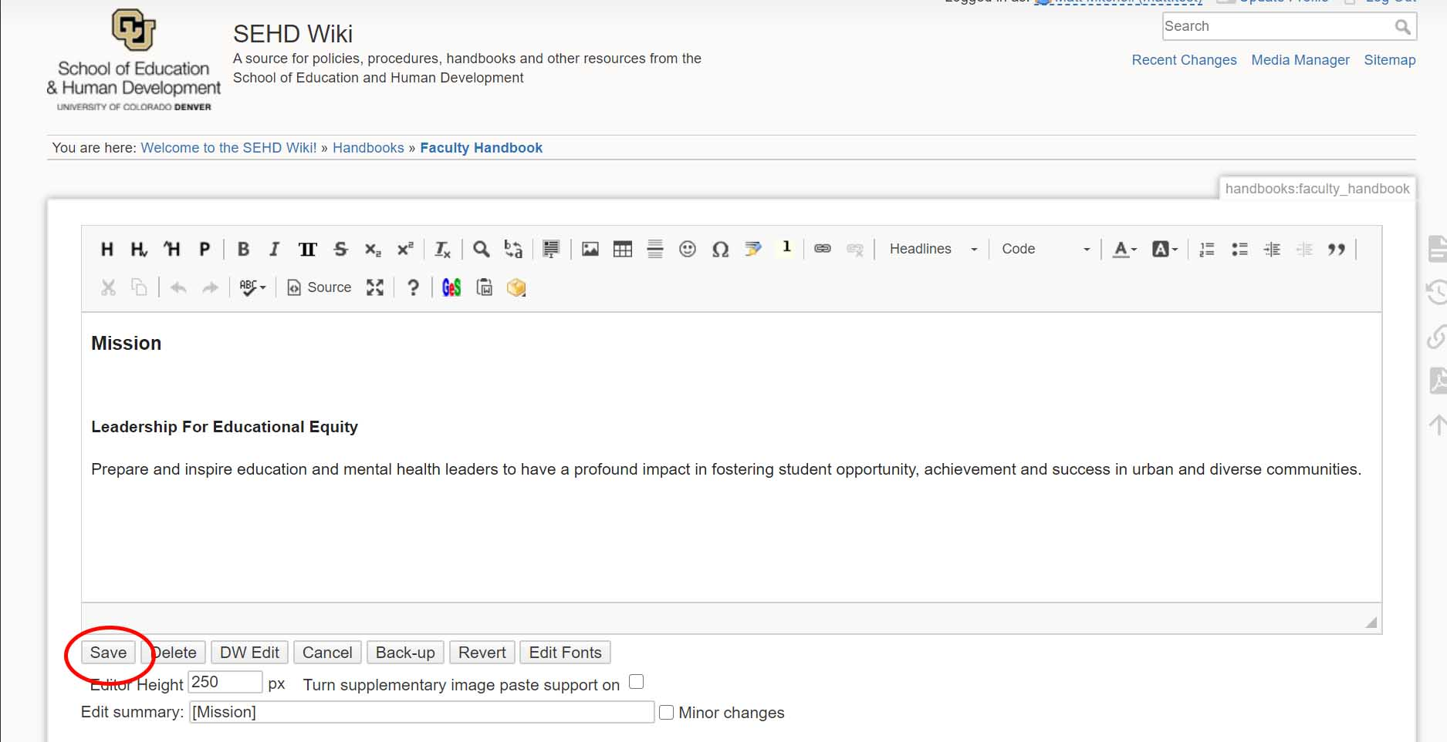4_save.jpg

5. This how to is meant to give you a quick introduction to making edits on the wiki. If you'd like to read more about what is possible with ckeditor please take a look at their documentation, a few examples are also highlighted below.
- Inserting images
- Pasting from Word
- Basic Text Styles
- Feel free to make edits and experiment in the Wiki Playground.

Request Access
Email sehdhelp@ucdenver.edu to request access to the Wiki.

